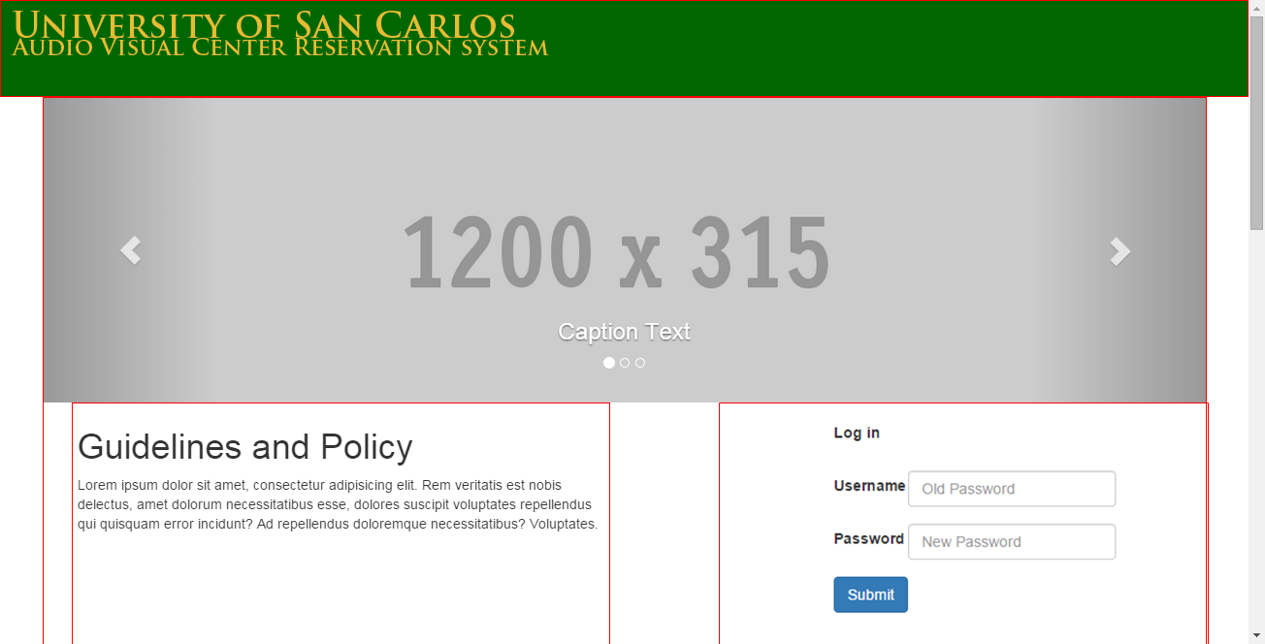

1. Carousel

* Description: Pictures will be shown
  + Action: None

1. Username Field
   * Description: User inputs his username
   * Action: None
2. Password Field

* Description: User inputs his username
  + Action: None

1. Submit
   * Description: Button
   * Action: Redirects to login.php to validate the account
2. Submit
   * Description: Displays the guidelines of using the Hall
   * Action: None